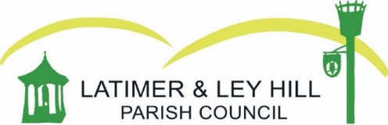

Councillors are hereby summoned to attend a MEETING OF THE PARISH COUNCIL to be held on Thursday 17th July at Ley Hill Memorial Hall, Ley Hill, 7.15pm
Members of the public and press are entitled to be at the following meeting in accordance with the Public Bodies (Admission to Meeting) Act 1960 Section 1 extended by Local Government Act 1972 Section 100 unless precluded by the Parish Council by resolution during the whole or part of the proceedings. Such entitlement does not however include the right to speak on any other matter except at the commencement of the meeting given over specifically for that purpose.
Agenda
- Apologies for absence

- Register of Interests

- Public quarter hour

- Approval of minutes from 19th June

- Actions from last meeting

- Finance
  - Approval of June finance report

- Burial Ground

  - Enquiries
  - Memorial permit for approval
  - Date for BG committee meeting

- Planning

  - PL/25/1624/AV – The Crown, Ley Hill
  - 25/01535/MFA – Solar Farm
  - ES/24/00367/OPHH – Trail End, Jasons Hill
  - PL/25/1768/FA - White End Park Farm

- Council Business

  - Outstanding issues raised with Buckinghamshire Council
  - Website
  - Signage – Blackwell Hall Lane
  - Drainage
  - Trail repairs
  - Buses
  - Ashley Green and Whelpley Hill Neighbourhood Plan

Signed: 
Date: 14 – Jun - 2025

