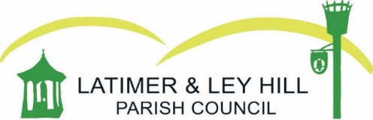

Councillors are hereby summoned to attend a MEETING OF THE PARISH COUNCIL to be held on Tuesday 09 January at Ley Hill Memorial Hall, 7.15pm
Members of the public and press are entitled to be at the following meeting in accordance with the Public Bodies (Admission to Meeting) Act 1960 Section 1 extended by Local Government Act 1972 Section 100 unless precluded by the Parish Council by resolution during the whole or part of the proceedings. Such entitlement does not however include the right to speak on any other matter except at the commencement of the meeting given over specifically for that purpose.
Agenda
- Apologies for absence

- Register of Interests

- Public quarter hour

- Approval of minutes from 28th November

- Actions from last meeting

- Finance
  - Approval of November and December finance reports
  - 2024 budget approval

- Burial Ground

  - Enquiries

- Planning
  - Applications for consideration
    - PL/23/3962/FA – Magnolia Cottage, Jasons Hill

- Council Business

  - Meeting dates 2024
  - Road sign cleaning
  - Christmas tree
  - Activity trail maintenance
  - Crown Cottage drainage – update
  - Ley Hill School – update from new headteacher

Date of future meeting: TBC

