Burial Ground
Sub Committee Minutes
4th September, 7pm

In Attendance
Claire Leek (CL), Anne Birkett (AB), Rae Bramwell (RB), Chris Harris (CH)

Remembrance Garden
The laurel bushes have been removed by Paul Empson and the area looks much better. There is a need to weed and tidy the remembrance garden and the committee propose covering the area with chippings to improve the overall appearance. A weed membrane underneath the chippings will be required. It was suggested that we plant some small, flowering shrubs (tbc) in a structured manor, possibly a straight line through the middle, in Spring. This gives us time to budget for the plants and also to seek advice on the best plants to use, taking into account the conditions – it is a very dry area due to the large trees and the plants will be almost always in shade. We propose to ask the community if anyone has any suggestions, and possibly any time spare to plant them.

The post box for the letters to heaven needs a plaque for the front as the laminated card has faded in the short amount of time it has been in position. This will simply read “Letters to Heaven” and will be attached to the front of the box. A second plaque will be mounted on a post next to the post box, and will provide a little more detail on what the post box is intended for.

ACTIONS
CL to order plaques. CH to arrange for post and mounting of plaques once they arrive.
AB to ask Karl or Paul Empson if they have any chippings available.

Gate
The small gate at the bottom, front of the burial ground no longer closes. The hinges are bent and prevent the gate from being closed. The hinges need to be removed and replaced, and a new catch is required.
We propose to ask for DIY help via the newsletter.

Headstones and Memorial Plots
Following a walk around the burial ground it was agreed that a clearance of all loose items that are not permitted to be left on plots will be carried out in line with the litter blitz in Ley Hill in October. This provides an opportunity for the PC to remove the items that need to be cleared and have a way of disposing of them.
There are also a number of areas around the burial ground where self seeded plants or plants that have been left at memorial plots have grown and are looking untidy. These need to be cut back or removed.

ACTIONS
CL to arrange for loose items to be cleared and collected for disposal.
CH to meet at the burial ground with Callum Wilson to run through the areas that we would like tidied up. This is likely to have an additional cost.

Hedge Cutting
The rear hedge is in need of a cut. This was last cut October 2021. This is usually carried out by The Chiltern Society every 2 years however, they are not able to dispose of the cuttings. Last time we made a donation to the Chiltern Society of £200 and paid £230 to have the cuttings removed and disposed of. We propose asking for a quotation from Callum Wilson, the burial ground maintenance contractor, to cut the rear hedge down substantially, in line with the small rear gate. This will open up the burial ground and allow visibility of the views across the fields. Callum cuts the front hedge as part of the maintenance contract.

ACTIONS

CL to obtain quote for the hedge to be cut Oct/Nov.

Next Meeting
Date | time to be confirmed.

Approved
Approved at PC meeting on 13th September 2023

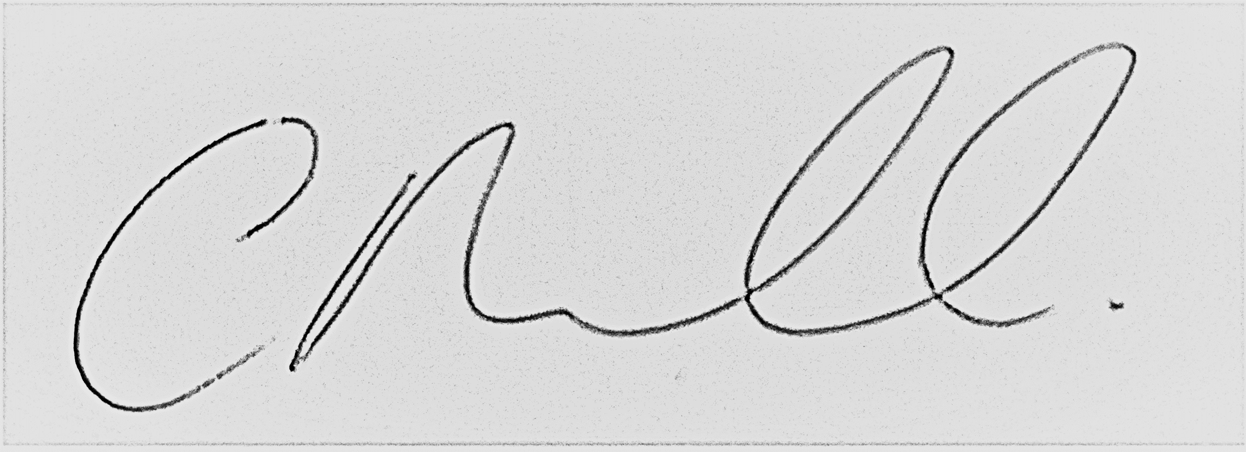
__________________________________________________________
Claire Leek
Clerk, RFO and Burial Ground Administrator.

