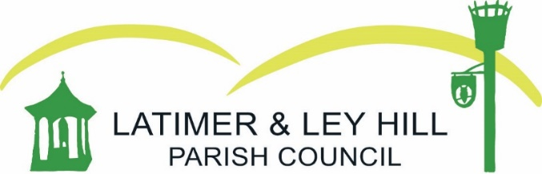

ANNUAL PARISH MEETING
Tuesday 26th April 2022 at The Methodist Church Hall, Ley Hill at 7.30pm

AGENDA

- Chairman’s Statement – Cllr Anne Birkett

- Financial commitments of the Parish Council – Parish Clerk

- Questions for the Councillors – Public

